Independent-Samples t Test – Example 2 (Self-esteem) ANSWER KEY

You are a researcher who is interested in determining whether dressing professionally increases self-esteem. You asked one group of participants to dress casually and a different group of participants to dress professionally for 1 week. At the end of the week, participants completed a self-esteem evaluation. The scores are listed below in the tables.

Step 1. State your hypotheses.
a. Is it a one-tailed or two-tailed test?
- One-tailed

b. Hypotheses in words:
H_{A}: The professional group will have higher self-esteem scores than the casual group.

H₀: The professional group will have lower or the same self-esteem scores as the casual group.

c. Hypotheses in symbols:
H_{A}: µ_{professional} - µ_{casual} > 0
H₀: µ_{professional} - µ_{casual} < 0

Step 2. Set the significance level ➔ α = .05 Determine t_{crit}. t_{crit} = +1.833

Step 3. Compute the appropriate statistical test.

SS₁ = 1312.8 SS₂ = 819.34
Professional Group  (X₁) |  | X – | (X –)²
98 | 121.8 | -23.8 | 566.44
120 |  | -1.8 | 3.24
149 |  | 27.2 | 739.84
122 |  | 0.2 | .04
120 |  | -1.8 | 3.24
ΣX = 609 |  |  | SS = Σ(X –)² = 1312.8
= 121.8
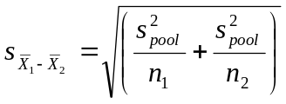
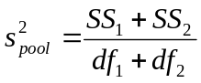

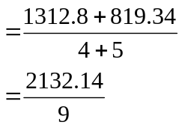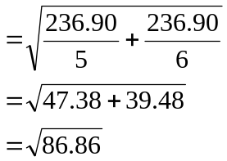

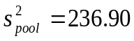
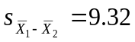
Casual Group  (X₂) |  | X – | (X –)²
86 | 92.67 | -6.67 | 44.49
99 |  | 6.33 | 40.07
95 |  | 2.33 | 5.43
94 |  | 1.33 | 1.77
72 |  | -20.67 | 427.25
110 |  | 17.33 | 300.33
ΣX₂ = 556 |  |  | SS = Σ(X –)² = 819.34
= 92.67

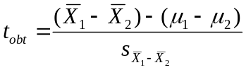

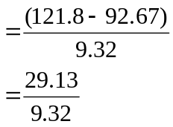

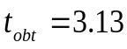

Step 4. Make a decision. Determine whether the value of the test statistic is in the critical region. Draw a picture.
Is t_{obt} in the critical region? yes
Should you reject or retain the H₀? reject t_{obt} = 3.13

t_{crit} = +1.833
Step 5. Report the statistical results.
t(9) = 3.13, p < .05

Step 6. Write a conclusion.

The group who dressed professionally (M = 121.8) had significantly higher self-esteem scores than the group who dressed casually (M = 92.67), t(9) = 3.13, p < .05.

Step 7. Compute the estimated d.
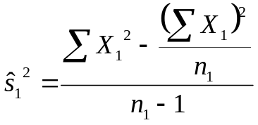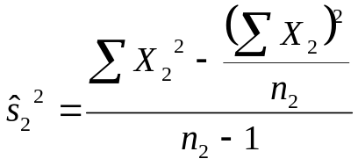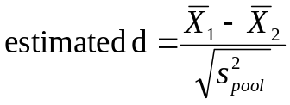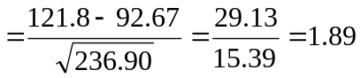
d Effect Size
0.2 Small effect
0.5 Medium effect
0.8 Large effect

Step 8. Compute r² and write a conclusion.
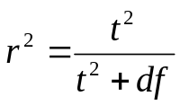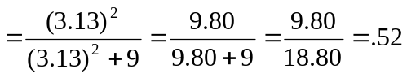
r2 Percentage of Variance Explained
0.01 Small effect
0.09 Medium effect
0.25 Large effect

Style of dress accounts for 52% of the variance in self-esteem.

